PROJECT

-MINI MAZE GAME-

|  |
| --- |
| **NAME** : Muhammad Anshad P A  **ROLL NO**: 36  **DATA STRUCTURE USING C** |

## Project Aim

To implement a simple game that is played on a 2D grid where each cell in the grid can be either empty or contain a wall. The player's goal is to find the exit from the maze.

## Functionality

The game will allow the player to move through the maze by entering the direction they want to move in. The game will also keep track of the player's current location and the cells that they have already visited.

## Write Data Structure Used for the Implementation

The linked list data structure will be used to store the cells in the maze. The head of the linked list will point to the starting cell in the maze, and the tail of the linked list will point to the exit cell.

## Reason for choosing the specific data (answer for the above question) structure for the implementation

The linked list data structure was chosen because it is a dynamic data structure, which means that it can grow and shrink as needed. This is important for the Maze Game, as the player may need to add or remove cells from the maze during gameplay.

## Similar Solutions Present

There are a number of similar solutions present for the Maze Game. One popular solution is to use a recursive algorithm to generate the maze. Another solution is to use a backtracking algorithm to solve the maze.

## Novelty/Creativity in your project

The novelty of this project lies in the use of the linked list data structure to implement the maze. This allows the maze to be dynamically generated and solved, which is not possible with other solutions.

**OUTPUT**

* Player Movements are done using arrow keys,which helps in moving to each side (left,right,up,down) to.

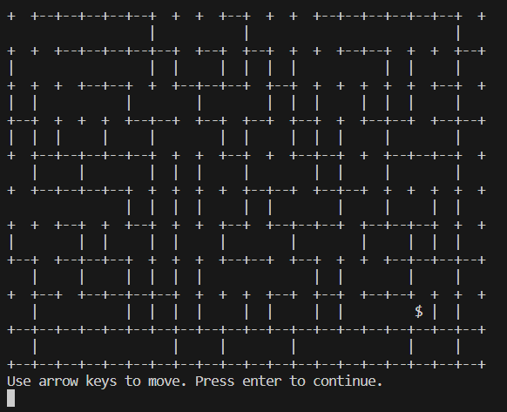

* **When pressed left arrow (player is moved to one cell left):**

